Name: Date:

Latitude/Longitude and Reading a Map

Directions: Circle the correct answer and then record the letter on the line.

- What are latitude and longitude lines?

a. Long and short lines that divide the earth
b. Imaginary lines that divide the earth
c. Visible lines that run across the earth

2. True or False. The equator is the main line of longitude.

a. True
b. False

3. This is the main line of latitude.

a. The Prime Meridian
b. The equator
c. The northern hemisphere

4. Which cuts the world into north and south latitude?

a. Equator
b. Prime Meridian
c. Longitude

5. This marks the location of the equator on Earth.

a. 0° Longitude
b. 60° Latitude
c. 0° Latitude

6) The Prime Meridian is marked as

a. 0° Longitude
b. 20° Longitude
c. 0° Latitude

Fill in the blanks using the word bank:

Vertically | Meridian | Horizontally
North | Longitude | Degrees
Latitude | South | Grid

1) Longitude lines run from pole to pole.

2) The intersection of earths latitude and longitude lines form a

3) Lines of latitude run .

4) Lines of latitude run .

5) Lines of locate places East or West of the Prime Meridian.

6) Lines of locate places North or South of the equator.

7) Longitude and latitude are measured in .

8) Longitude and latitude lines are also called lines.

Directions: Use the map to answer the following questions.

United States Map – Common Core Alignment: CCSS.ELA-Literacy.RI.3.4
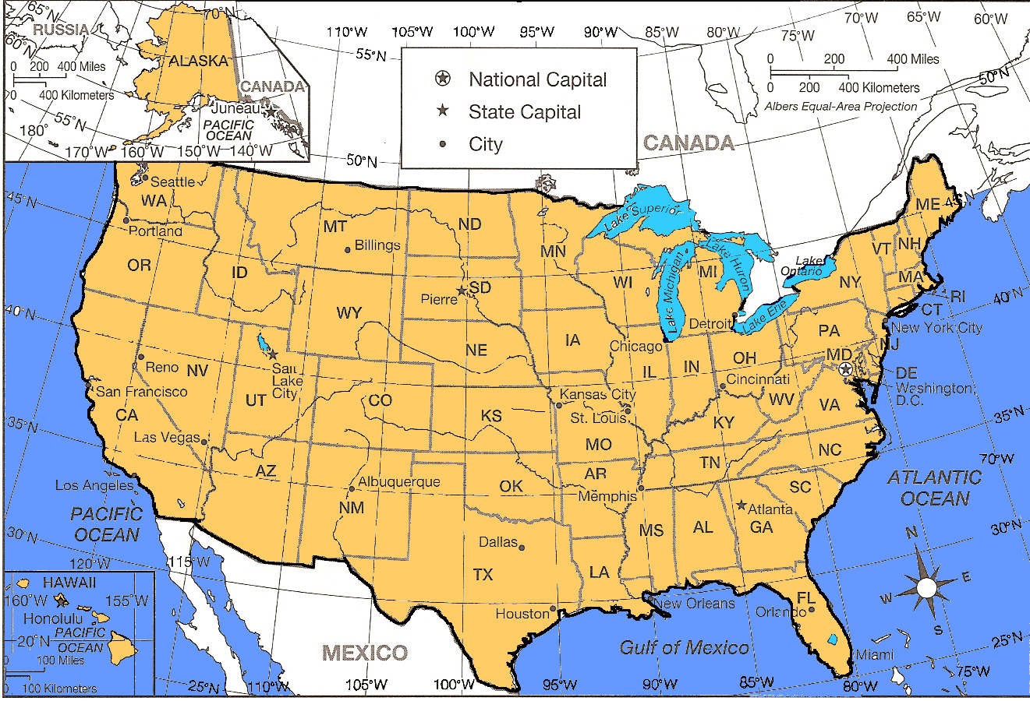

Using abbreviations, list 5 different groups of 3 or more states that are on the same line of longitude

1.

2.

3.

4.

5.

Using abbreviations, list 5 different groups of 3 or more states that are on the same line of latitude

1.

2.

3.

4.

5.

Name two sets of cities that are on (or very close to) the same line of longitude

1.

2.

Name two sets of cities that are on (or very close to) the same line of latitude

1.

2.

According to the key what are the symbols for different labels on the map:

1. What does a plain star mean?

2. What does a star with a circle around it stand for?

3. What does a dot stand for?

What are other symbols on that map that you think have a specific meaning? (ex. Blue lines, black lines around states, large masses of blue) Name at least 4 and what you think they stand for.

1. =

2. =

3. =

4. =

HOPE YOU ENJOY THE REST OF YOUR DAY!

