Name: Date:

Directions: Find a coordinate from each continent and provide it on the lines provided. Be sure to include the same of the continent with each coordinates.

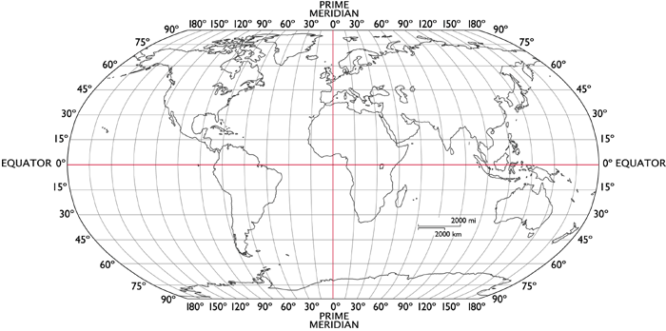

1.
2.
3.
4.
5.
6.
7.

