Name: Date:

Visual Discovery Activity One - Longitude, Latitude, and Maps:

Directions: Carefully examine the following image and answer the questions. Part of this activity we will be answering as a group, other parts you will be doing in pairs or individually. The image is printed on page 3, feel free to un-staple it

As a class:
What do you see in this image?

In pairs:
What are different symbols on this map that you notice? (ex. Roads, rivers, etc.) How can you tell what the symbols stand for?

Individually:
Pretend you are actually on this map. Thoroughly explain the details and features that you see. How would they would feel if you could touch them? What do you think they stand for?

What do you think is the purpose of putting different features on a map? How do you think it could be helpful for someone?

Consider this picture as a whole. Why do you think there are different features in some parts of the map compared to others? What do you think are different geography features you would see if you were to physically walk across Florida? Note: Florida is located in the bottom right quadrant of the map.

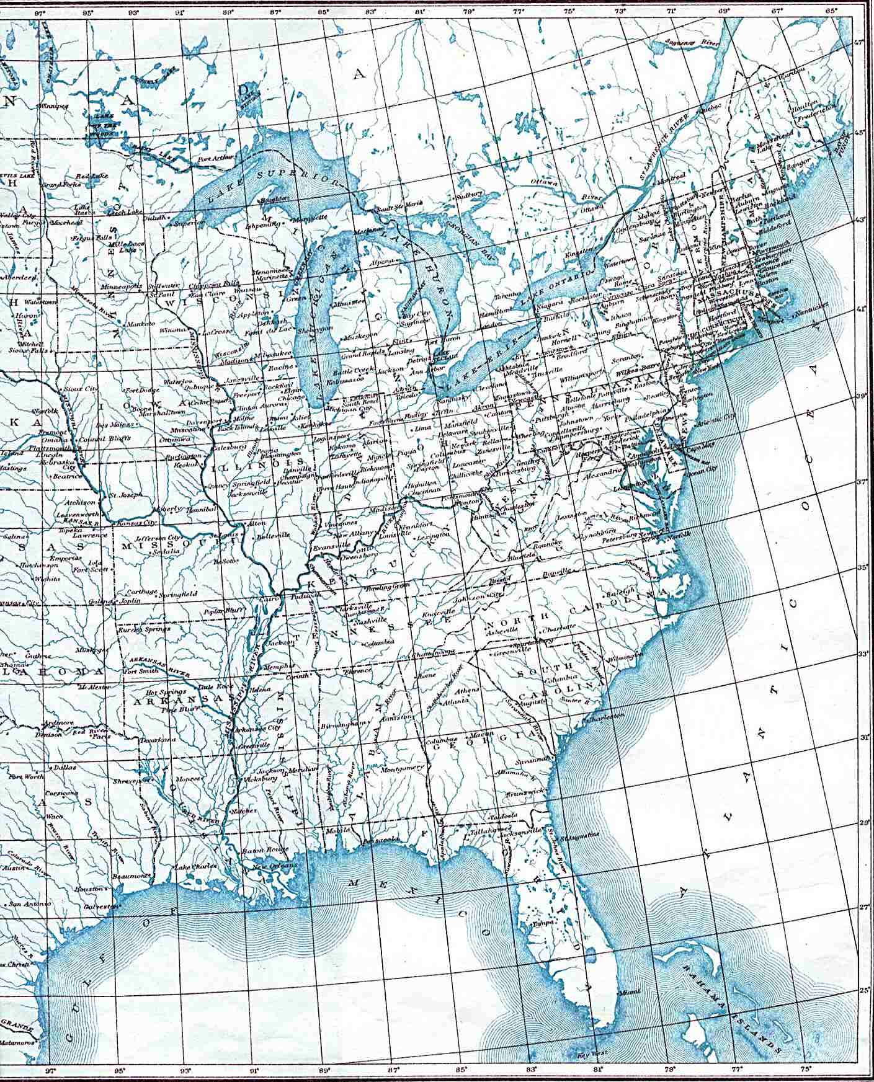
Image 1: East side of the U.S

Kristen Calidonna

