Visual Discovery Activity 2 - Latitude, Longitude, and Maps

Name: Date:

Directions: Analyze the picture below and answer the questions. When you have been told to do so, read the passage and continue answering the questions. The questions will either be answered as a class, in pairs, or individually, so make sure you read the directions above each one.

North America
Analyze this picture by yourself for 10 minutes (Wait for the teacher to tell you to stop)
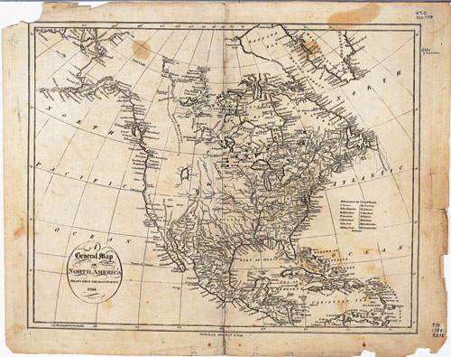

Directions: Read these paragraphs thoroughly, looking for at least 7 details that you also saw in the picture above.

Geography
Maps and globes can be used to locate places in our country and on our earth. There are many ways to find specific places on a map or globe. People who created maps thought o g imaginary lines that would help us find places.
There is an imaginary line that runs around the center of Earth. It divides into a north half and a south half. The line is called the equator. The two halves that the equator splits into are called hemispheres.
There is also an imaginary line that runs around the center of the earth. This time, it divides into two hemispheres, the eastern hemisphere and the western hemisphere. This imaginary line is called the prime meridian.
Imaginary lines are all over globes and maps. Longitude lines run north to south, all around the globe. Latitude lines run east to west. By using latitude and longitude people can find specific locations on a map or globe.
(http://www.teacherspayteachers.com/Product/Geography-Latitude-Longitude-Differentiated-Reading-Passages-Questions-1037976)

What are 7 details that you noticed in both the picture as well as the reading?
1)
2)
3)
4)
5)
6)
7)

Think back to your reading, can you find 5 details that were in the reading but that you didn’t see in the picture? What are they? Discuss with a partner and then record your answers.

1)
2)
3)
4)
5)

When you are finished put your pencils down and look forward so I know that you are ready. We will now discuss your findings as a class so we can compare them to one another!

