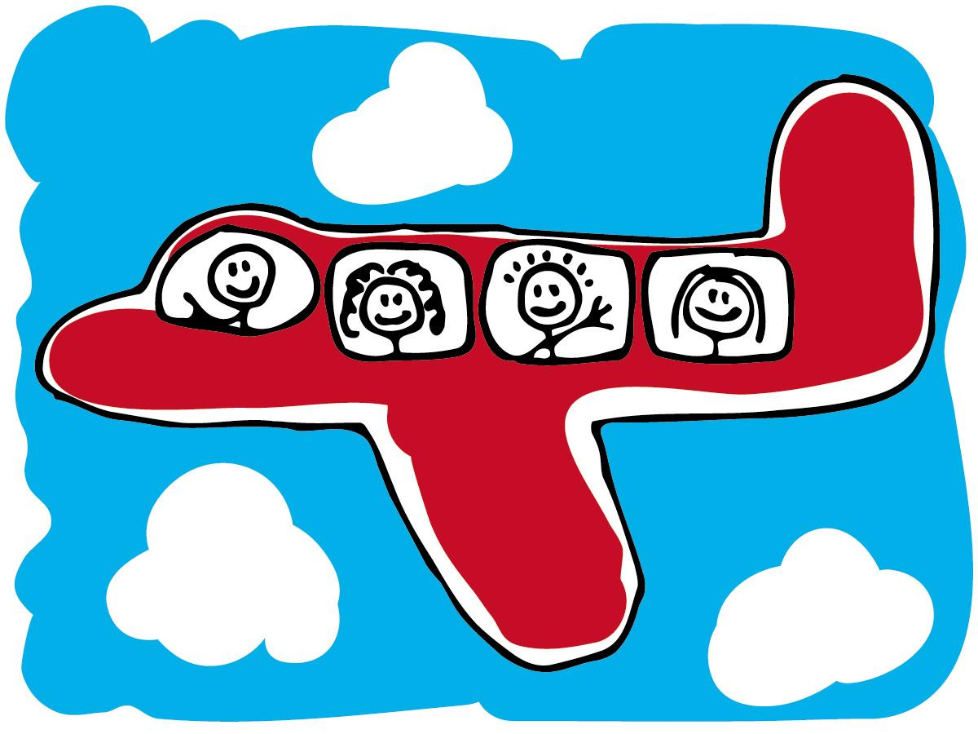

Name: Date:

Simulated trip: As a class we are going for a trip around the world. On this trip we will be able to see all the features of the world below us outside of our airplane window. We will be soaring from continent to continent. As we pass through each continent, we will be calling out which it is as well as where it is located on the map. This will include, the hemisphere, the location in comparison to the Equator and to the Prime Meridian, one set of coordinates in the continent, and any other features you may notice. We will be briefly landing on each continent so students will need to decided which city they want to land in and they will need to tell the pilot the coordinates of that particular city.

